Tennis Growth Platform
BRD • PRD • Design Brief • Technical Direction • Screen Inventory • Pitch Summary
Prepared for product planning and investor conversations
Date: 24 July 2026

Platform Area | Primary Users | Channel
Mobile App | Tennis players, learners, coaches, casual players | Flutter iOS/Android
Community/Club Admin Web App | Clubs, academies, court managers, coaches, event organizers | Next.js web app
Platform Management Dashboard | Internal operations, support, finance, content, compliance, growth team | Next.js admin dashboard
Backend/API | All products, integrations, analytics, notifications | NestJS API layer

1. Executive Summary
The proposed platform is a tennis and padel ecosystem that helps players discover courts, find opponents, join communities, read tennis news, learn through guided tips, track skill improvement, and engage with clubs and coaches. It combines match organization with learning, progress tracking, court discovery, club management, and platform-level administration.
The product will include a Flutter mobile app for players, a Next.js web app for community and club administrators, and a Next.js internal management dashboard. A NestJS backend will power authentication, users, court data, communities, bookings, news aggregation, learning content, progress tracking, notifications, subscriptions, and analytics.
Strategic Pillar | What it delivers
Play | Find opponents, join ladders/leagues, organize matches, record results.
Learn | Access beginner-friendly tennis tips, drills, lessons, and structured learning paths.
Improve | Track serving, forehand, backhand, volley, footwork, match strategy, and confidence growth.
Discover | Find tennis courts, Google Business Profile data where available, contacts, directions, coaches, events, and booking links.
Connect | Build local tennis communities around clubs, courts, academies, and events.

2. Business Requirements Document (BRD)

2.1 Business Problem
Many tennis players struggle to find nearby courts, reliable booking contacts, suitable playing partners, beginner-friendly learning resources, organized club activities, and clear ways to measure improvement. Clubs and academies also lack lightweight tools to manage community engagement, events, court visibility, coaching programs, and communication with players.

2.2 Business Goals
- Increase tennis participation by helping users find courts, players, lessons, and communities.
- Help beginners progress from casual interest to confident play through guided learning and measurable skill tracking.
- Provide clubs and academies with admin tools to manage venues, communities, events, coaches, contacts, and announcements.
- Create a scalable platform that can expand from one city to multiple markets.
- Build revenue streams through club subscriptions, premium player features, event fees, booking commissions, sponsorships, and coaching marketplace partnerships.

2.3 Target Users
User Segment | Needs | Key Value Proposition
Beginner player | Find courts, learn basics, track progress, meet friendly players | A guided path from learning to playing.
Intermediate/advanced player | Find competitive matches, track performance, join ladders and leagues | Better competition and measurable improvement.
Coach | Promote services, manage learners, assign drills, provide feedback | Digital coaching and client growth.
Club/community admin | Manage court profiles, events, members, announcements, and booking contacts | Simple community operations and visibility.
Platform admin | Control content, sources, users, clubs, roles, analytics, disputes, monetization | Safe, scalable, and manageable operations.

2.4 Scope
In Scope | Out of Scope for MVP
User registration, profile, player level, preferences | Advanced AI video stroke analysis
Court discovery map with profile cards and contact/booking links | Native booking/payment for every venue
Community/club pages and admin management | Wearable integrations
News aggregation using approved sources/RSS/APIs with redirects | Full article republication without publisher permission
Learning tips, drills, goals, progress tracking | Professional certification replacement or medical/fitness diagnosis
Internal admin dashboard and analytics | Complex ERP-style club accounting

2.5 Success Metrics
Metric | Example Target
Activation | 60% of new users complete profile, skill baseline, and first court search.
Engagement | 40% monthly active users log a match, practice session, or learning activity.
Court coverage | 200 verified courts/profiles in first launch market.
Community adoption | 50 clubs/communities onboarded in first 6-12 months.
Retention | 30-day retention above 35% for users who join a community or log progress.
Revenue | Paid club/community subscription conversion from verified venues.

3. Product Requirements Document (PRD)

3.1 Product Vision
To become the operating system for everyday tennis: helping players discover where to play, who to play with, how to improve, and how to stay connected to local tennis communities.

3.2 Core Modules
Module | User Outcome | Primary Product
Authentication & Profiles | Users create tennis identities with skill level, preferences, location, and goals. | Mobile + Web
Court Finder | Users find nearby courts, view maps, contact venues, and open booking/direction links. | Mobile
Club/Community Management | Admins manage venue profiles, members, events, announcements, coaches, and booking details. | Admin Web
News Feed | Users view tennis highlights, source attribution, summaries, and links to publishers. | Mobile + Admin moderation
Learn/Tips | Users access structured beginner tips, lessons, drills, and learning plans. | Mobile + Admin content
Progress Tracker | Users track serve, forehand, backhand, volley, footwork, return, strategy, and mental game. | Mobile
Matches & Leagues | Users organize matches, submit scores, join ladders/leagues, and view standings. | Mobile + Club Admin
Internal Management | Platform team manages users, content, courts, clubs, reports, roles, billing, and analytics. | Dashboard

3.3 MVP Feature Requirements
Feature | Requirement | Priority
User onboarding | Sign up, location, preferred courts, player level, goals, availability. | Must
Court map | Show tennis courts near user with pins, profiles, ratings where available, contacts and directions. | Must
Court profile | Display court type, address, booking contact, Google link, photos, amenities, opening hours when available. | Must
News highlights | Aggregate approved RSS/API sources, summarize highlights, attribute source, redirect to original story. | Should
Learning centre | Organize tips by serve, forehand, backhand, volley, footwork, rules, strategy, fitness. | Must
Skill baseline | Capture user self-assessment and first measurements for key skills. | Must
Practice log | Allow session tracking, drill results, notes, confidence, duration, photos/videos in later phase. | Must
Goals | Set measurable goals by skill area with milestones and deadline. | Must
Community admin | Admins create club/community profile, manage members, announcements and events. | Must
Platform dashboard | Internal team manages users, clubs, courts, content, news sources, analytics and reports. | Must

3.4 Non-Functional Requirements
- Performance: mobile screens should load quickly on mid-range Android devices; map and list views should use pagination/clustering.
- Security: role-based access control, secure APIs, rate limiting, input validation, JWT/session hardening, audit logs for admin actions.
- Privacy: clear location permissions, user control over profile visibility, private skill notes, and safe data handling.
- Scalability: multi-market architecture for countries, cities, clubs, courts, and communities.
- Reliability: graceful degradation if Google/Maps/news APIs fail; cache venue metadata and news summaries.
- Accessibility: clear typography, sufficient contrast, large touch targets, screen-reader-aware components, and keyboard support on web.

4. Design Brief

4.1 Brand Direction
The interface should feel energetic, sporty, modern, trustworthy, and beginner-friendly. It should avoid intimidating competitive-only language and instead communicate growth, discovery, and community.
Design Principle | Application
Beginner-first clarity | Use simple labels such as Learn, Play, Improve, Courts, Community.
Progress visible | Make improvement feel measurable through charts, badges, goals, and encouraging insights.
Local discovery | Use maps, venue cards, distance, directions, contacts, and community signals.
Trust and safety | Clear source attribution for news, verified venue badges, role permissions, and privacy controls.
Mobile-first speed | Prioritize fast actions: find court, log practice, join community, read tip, contact venue.

4.2 Suggested Visual Language
- Color palette: ATP-inspired deep blue direction with an independent brand identity. Primary #12085B, secondary #1F2F8F, accent #2F59D9, with #D7FF3F used sparingly as a tennis-energy accent.
- Typography: modern sans-serif, clear hierarchy, strong numbers for stats and scores.
- Components: map cards, skill meters, progress charts, lesson cards, venue profiles, event cards, ranking tables, admin tables.
- Tone: supportive, practical, encouraging, and competitive only where appropriate.

5. Technical Architecture
Layer | Recommended Stack | Notes
Mobile app | Flutter | iOS and Android app for players, learners, coaches, match participants.
Web apps | Next.js | Separate web applications or separate route groups for club admins and platform dashboard.
Backend | NestJS | REST or GraphQL APIs, modular services, background jobs, authentication, integrations.
Database | PostgreSQL | Users, courts, clubs, communities, matches, content, progress, roles, audit logs.
Cache/Jobs | Redis + queue workers | News ingestion, notifications, map caching, analytics jobs.
Maps/Places | Google Maps Platform / Places API | Search courts, profiles, coordinates, opening hours, photos, phone, website where available.
News ingestion | RSS/APIs + summarization workflow | Approved source list, metadata extraction, summarization, moderation, source linking.
Notifications | FCM + email provider | Match reminders, community updates, booking reminders, goal nudges.
Storage | Object storage | Images, club photos, optional practice media, content assets.

5.1 Backend Modules
- Auth & Identity: signup, login, password reset, social login, roles, permissions.
- Users & Profiles: player profile, skill level, preferences, location, privacy settings.
- Courts & Venues: court records, Google Places metadata, amenities, contacts, verification status.
- Communities & Clubs: members, roles, announcements, events, coaches, court profiles.
- Matches & Leagues: invitations, scheduling, scores, standings, disputes, availability.
- Learning Content: categories, tips, lessons, drills, levels, media, completion tracking.
- Progress: skill baseline, practice logs, goals, milestones, assessment history, charts.
- News: sources, ingestion jobs, summaries, topics, publisher redirects, moderation.
- Notifications: push/email templates, reminders, preferences, delivery logs.
- Admin & Audit: dashboards, reports, content moderation, user moderation, audit trails.

6. Screen Inventory

6.1 Mobile App Screens - Flutter
Area | Screen
Onboarding & Account | Splash
Onboarding & Account | Welcome
Onboarding & Account | Sign up
Onboarding & Account | Login
Onboarding & Account | Forgot password
Onboarding & Account | Location permission
Onboarding & Account | Choose playing level
Onboarding & Account | Select goals
Onboarding & Account | Select availability
Onboarding & Account | Select preferred courts/clubs
Onboarding & Account | Profile setup complete
Home | Home dashboard
Home | Quick actions
Home | Notifications
Home | Search
Home | Global app menu
Courts | Court map
Courts | Court list
Courts | Court filters
Courts | Court profile
Courts | Court photos
Courts | Google profile details
Courts | Booking contacts
Courts | Directions handoff
Courts | Report/update court info
Courts | Save court
Play | Find players
Play | Player profile
Play | Invite to match
Play | Match scheduling
Play | Match details
Play | Score submission
Play | Score confirmation
Play | Match history
Play | League list
Play | League details
Play | Standings
Play | Fixtures
Play | Dispute score
Learn | Learning home
Learn | Skill categories
Learn | Lesson details
Learn | Drill details
Learn | Saved lessons
Learn | Learning path
Learn | Video lesson
Learn | Lesson completion
Learn | Beginner rules/scoring
Progress | Progress dashboard
Progress | Skill profile
Progress | Serve tracker
Progress | Forehand tracker
Progress | Backhand tracker
Progress | Volley tracker
Progress | Footwork tracker
Progress | Return tracker
Progress | Practice log list
Progress | Add practice session
Progress | Goal list
Progress | Create goal
Progress | Goal details
Progress | Assessment history
Progress | Progress report
News | News feed
News | News categories
News | News story highlight
News | Saved stories
News | Follow players/topics
News | Open original source
Community | Community list
Community | Community profile
Community | Join community
Community | Community feed
Community | Announcements
Community | Events list
Community | Event details
Community | Coach directory
Community | Coach profile
Community | Member directory
Messaging | Inbox
Messaging | Chat thread
Messaging | Match quick replies
Messaging | System messages
Settings | Edit profile
Settings | Privacy settings
Settings | Notification settings
Settings | Subscription plan
Settings | Help/support
Settings | Terms/privacy
Settings | Delete account

6.2 Community/Club Admin Web Screens - Next.js
Area | Screen
Access | Admin login
Access | Accept invitation
Access | Choose club/community
Access | Admin profile
Dashboard | Club overview
Dashboard | Activity summary
Dashboard | Upcoming events
Dashboard | Member growth
Dashboard | Court engagement
Club Profile | Edit club profile
Club Profile | Google profile link
Club Profile | Photos/gallery
Club Profile | Amenities
Club Profile | Booking contacts
Club Profile | Opening hours
Club Profile | Verification request
Courts | Court list
Courts | Add/edit court
Courts | Court status
Courts | Court availability notes
Courts | Maintenance notices
Members | Member list
Members | Member profile
Members | Invite members
Members | Role management
Members | Approval requests
Coaches | Coach list
Coaches | Add/edit coach
Coaches | Coach availability
Coaches | Coach bookings contact
Events | Events calendar
Events | Create event
Events | Event attendees
Events | Announcements
Events | Tournament/ladder setup
Community Content | Posts/announcements
Community Content | Moderation queue
Community Content | Media library
Reports | Engagement reports
Reports | Court inquiry reports
Reports | Event reports
Reports | Member export
Settings | Club settings
Settings | Notification settings
Settings | Billing/subscription
Settings | Team roles
Settings | Audit log

6.3 Platform Management Dashboard Screens - Next.js
Area | Screen
Access & Control | Admin login
Access & Control | 2FA verification
Access & Control | Role management
Access & Control | Team users
Access & Control | Permission matrix
Overview | Platform KPI dashboard
Overview | Market/city dashboard
Overview | Growth analytics
Overview | Revenue dashboard
Overview | System health
Users | User list
Users | User profile
Users | Player activity
Users | Flags/reports
Users | Support notes
Users | Suspend/restore user
Courts/Venues | Venue database
Courts/Venues | Add/edit venue
Courts/Venues | Google Places sync status
Courts/Venues | Verification workflow
Courts/Venues | Duplicate merge
Courts/Venues | Court reports
Clubs/Communities | Club list
Clubs/Communities | Club profile
Clubs/Communities | Admin approvals
Clubs/Communities | Subscription status
Clubs/Communities | Community moderation
News | News source manager
News | Ingestion logs
News | Story moderation
News | Topic tagging
News | Summary review
News | Blocked sources
Learning Content | Content library
Learning Content | Create lesson
Learning Content | Create drill
Learning Content | Skill category manager
Learning Content | Learning path builder
Learning Content | Media assets
Progress Analytics | Skill engagement analytics
Progress Analytics | Practice log analytics
Progress Analytics | Goal completion analytics
Progress Analytics | Cohort reports
Matches/Leagues | Match list
Matches/Leagues | League list
Matches/Leagues | Dispute queue
Matches/Leagues | Score audit
Matches/Leagues | Tournament oversight
Monetization | Plans
Monetization | Invoices
Monetization | Payments
Monetization | Promotions
Monetization | Sponsors/ads
Support & Compliance | Support tickets
Support & Compliance | Content reports
Support & Compliance | Audit logs
Support & Compliance | Privacy requests
Support & Compliance | Terms/version management
Configuration | Countries/cities
Configuration | Feature flags
Configuration | Notification templates
Configuration | System settings
Configuration | API/integration settings

7. Key Data Entities
Entity | Description
User | Profile, role, location preferences, player level, privacy settings.
SkillProfile | Ratings and baseline values for serve, forehand, backhand, volley, footwork, return, strategy.
PracticeSession | Logged training session, drills, results, notes, confidence, duration.
Goal | Skill-specific target, baseline, target value, deadline, milestones.
Court/Venue | Location, contacts, Google Places data, amenities, status, booking links.
Club/Community | Venue-linked or independent tennis community with admins and members.
Match | Players, schedule, score, confirmation, reflections, dispute state.
League/Ladder | Competition structure, members, fixtures, standings, rules.
LearningContent | Tips, lessons, drills, skill categories, levels, media.
NewsStory | Source, headline, summary, topics, image, publisher URL, moderation status.

8. Investor Pitch Summary
Pitch Area | Summary
Problem | Tennis participation is blocked by court discovery friction, weak community coordination, lack of structured beginner support, and no simple progress tracking.
Solution | A mobile-first tennis ecosystem connecting players to courts, clubs, learning, progress tracking, news, events, coaches, and matches.
Market Opportunity | Start with tennis communities in launch cities, then expand by city, club networks, academies, schools, resorts, and national tennis bodies.
Product Advantage | Combines court discovery, community management, learning, and measurable player development in one platform.
Business Model | Club subscriptions, premium player plans, coaching marketplace fees, booking commissions, events, sponsorships, and targeted tennis promotions.
Go-to-Market | Pilot with selected clubs and courts, onboard coaches, run beginner challenges, launch city-based communities, and use tournaments/events to drive adoption.
Moat | Venue database, local communities, player progress data, club relationships, content library, and network effects between players, courts, coaches and clubs.

9. MVP Delivery Roadmap
Phase | Duration | Key Deliverables
Discovery & UX | 2-4 weeks | User research, information architecture, wireframes, design system foundations, screen flows.
MVP Build | 8-12 weeks | Mobile app, backend APIs, court discovery, learning, progress, club admin, platform dashboard basics.
Pilot | 4-6 weeks | Onboard first venues/clubs, validate court data, collect feedback, refine onboarding and progress tracking.
Commercial Launch | 6-8 weeks | Subscriptions, public marketing site, reporting, improved analytics, operations playbooks.
Expansion | Ongoing | Native booking, coach marketplace, advanced leagues, video progress, payments, partnerships.

10. Competitive Reference Review — Scala Screens
Reference set: 129 Scala mobile screenshots supplied by the product team. The screenshots are used as functional and UX references only. The proposed product should not reproduce Scala’s visual design, copy, or proprietary assets. The review informs requirements, edge cases, information architecture, and opportunities for differentiation.

10.1 Reference Capabilities Observed
- Authentication using email/OTP and onboarding
- Player profile setup: city, club/association, playing hand and self-rated level
- Play/home area with upcoming activity and recommendations
- Player discovery, profiles, connections and pending requests
- Direct messaging, season/group communication and system-generated match messages
- Flex leagues, seasons, rounds, registration, waitlists and player lists
- Standings, schedules, results, match detail, walkovers and season completion
- Singles/doubles ratings, match history, statistics and achievements
- Rules, scoring formats, help/FAQ, notifications and account settings
- Event discovery, event detail, organizer information and registration states

10.2 Product Opportunities Identified
- Make scheduling structured: Propose Time, Suggest Court, Book Court, Confirm, Reschedule and Cancel actions inside the match/chat flow.
- Separate official Announcements from conversational Community Chat.
- Use explicit labels for Standings, Results, Schedule and Details instead of relying on icon-only navigation.
- Define competition states centrally: Draft, Registration Open, Enrolled, Active, Completed, Cancelled; and match states: Proposed, Scheduled, Played, Walkover, Retirement, No-show, Disputed, Cancelled, Expired.
- Treat competitive rating and skill development as separate concepts: an overall rating answers “how competitive am I?” while Serve/Forehand/Backhand/Volley/Return/Movement/Match Play answer “where am I improving?”
- Improve location relevance and privacy: use preferred areas/courts, distance filters and approximate public location rather than precise player location.
- Connect player discovery to availability, preferred courts, level, singles/doubles preference and casual/competitive intent.
- Resolve end-of-season edge cases explicitly when matches remain unplayed.
- Use consistent registration language and status feedback across events, leagues and waitlists.
- Extend the ecosystem beyond competition with court discovery/booking, learning, progress tracking, coaches and tennis news.

10.3 Reference Screens — Selected Examples
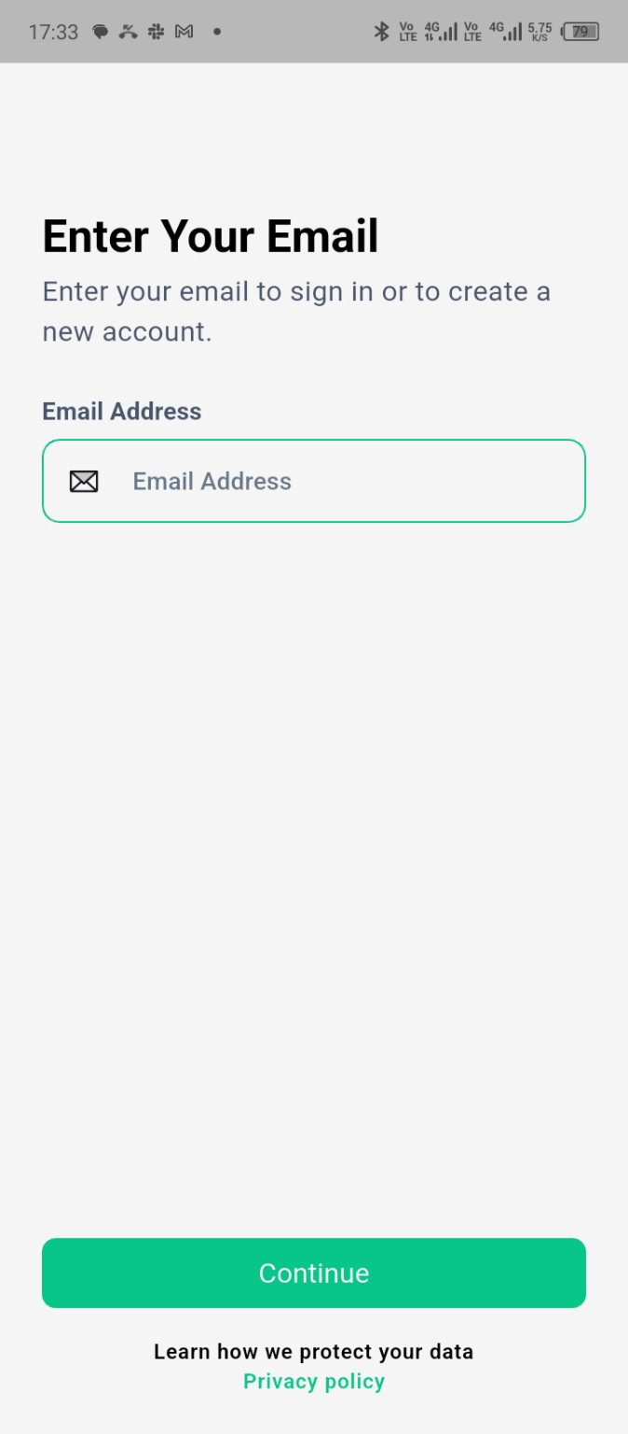 | 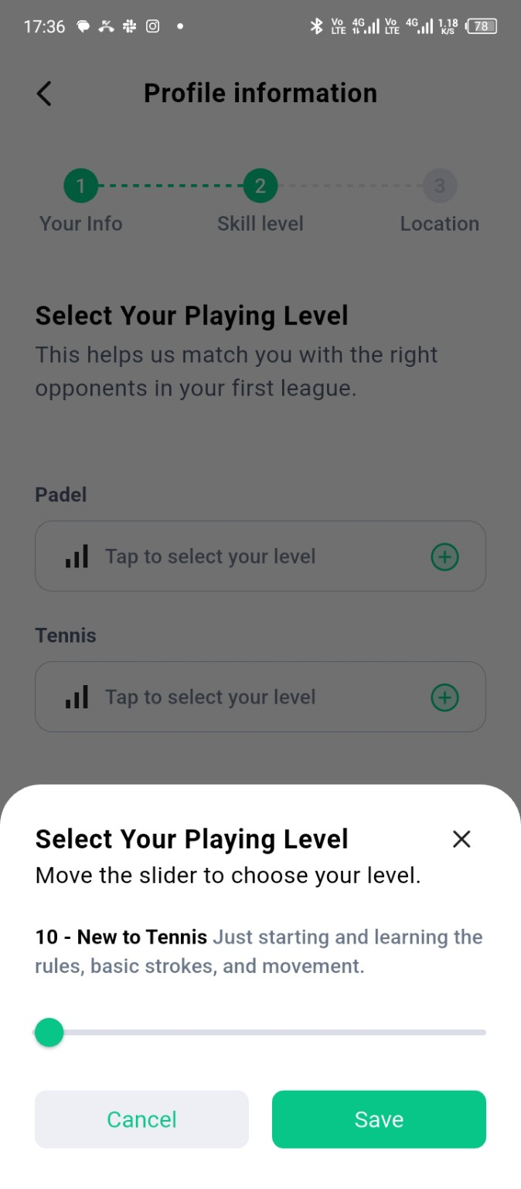
Scala reference — 1001832832.jpg | Scala reference — 1001832844.jpg

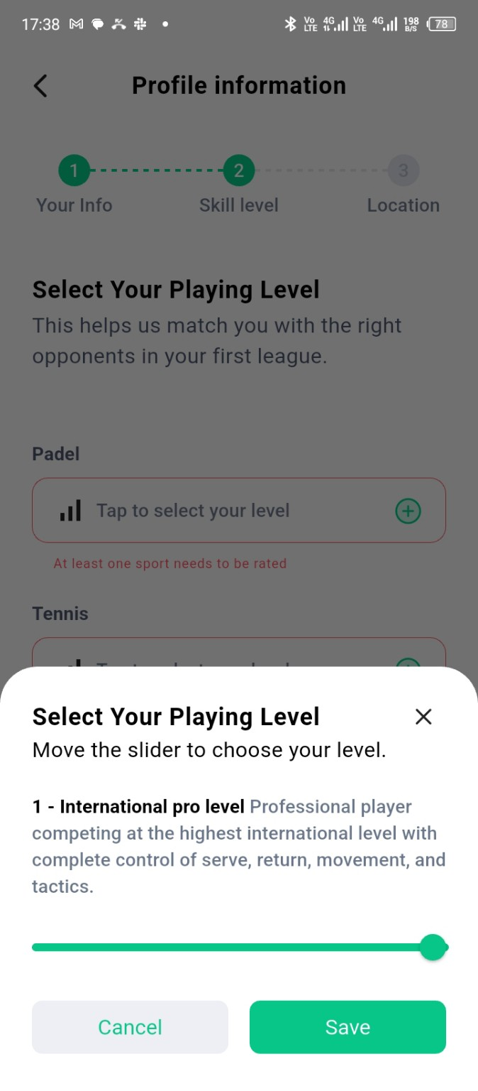 | 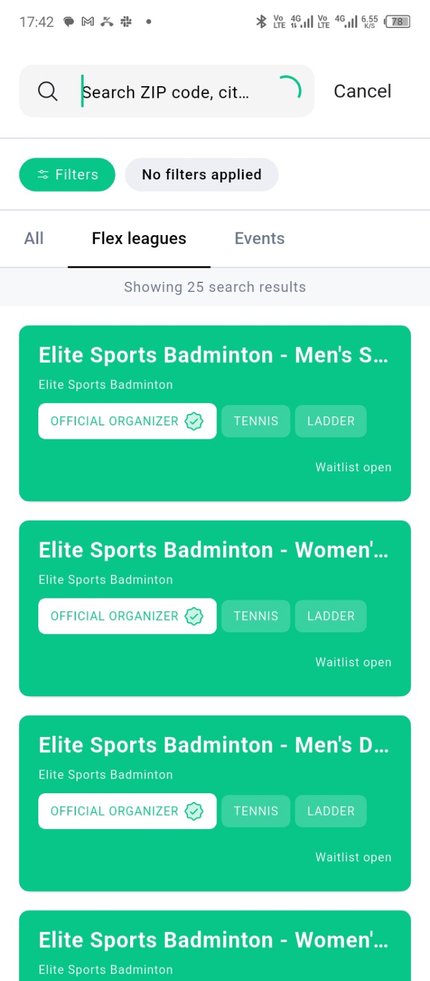
Scala reference — 1001832854.jpg | Scala reference — 1001832864.jpg

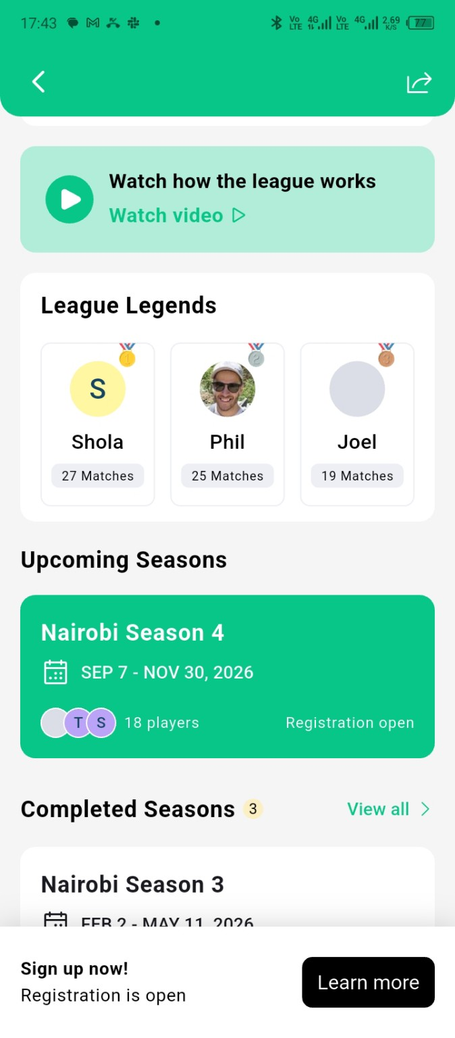 | 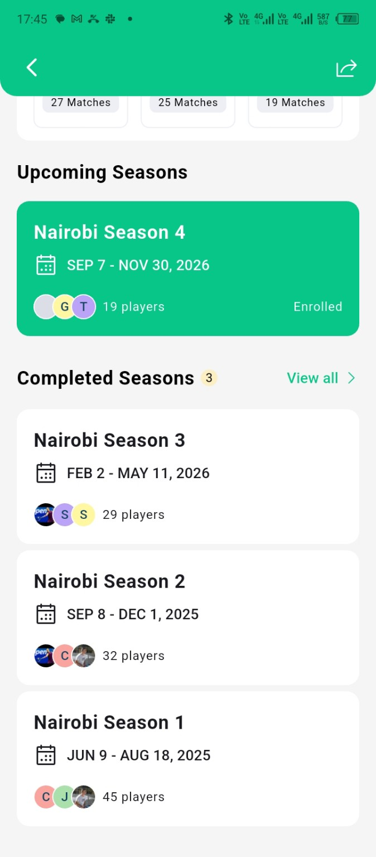
Scala reference — 1001832873.jpg | Scala reference — 1001832884.jpg

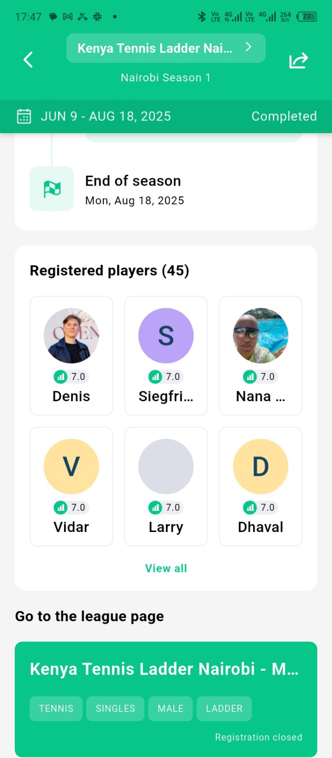 | 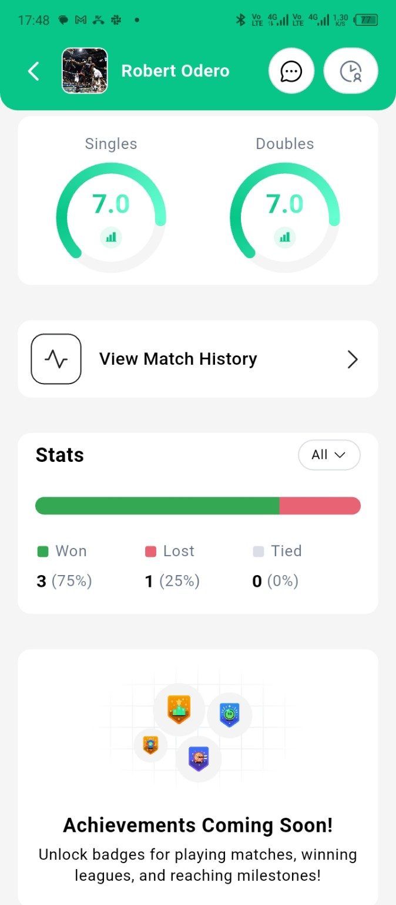
Scala reference — 1001832894.jpg | Scala reference — 1001832903.jpg

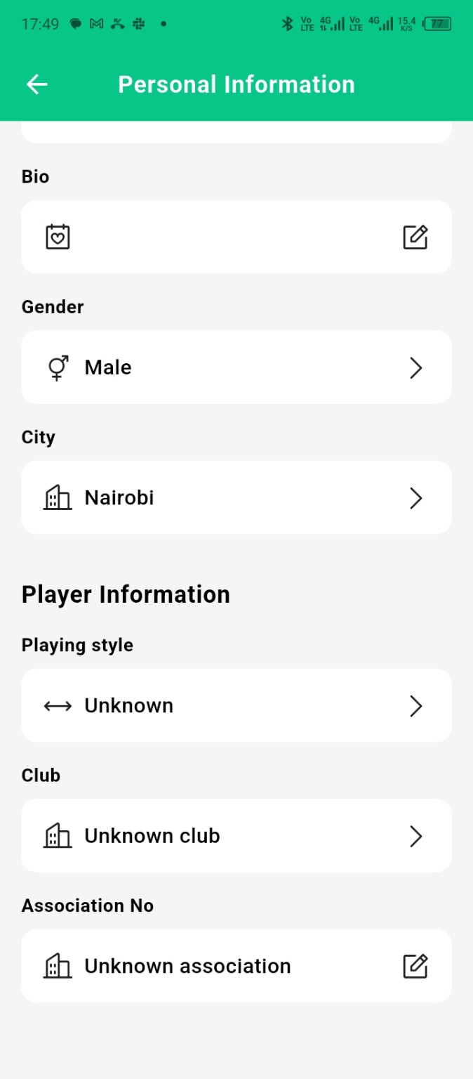 | 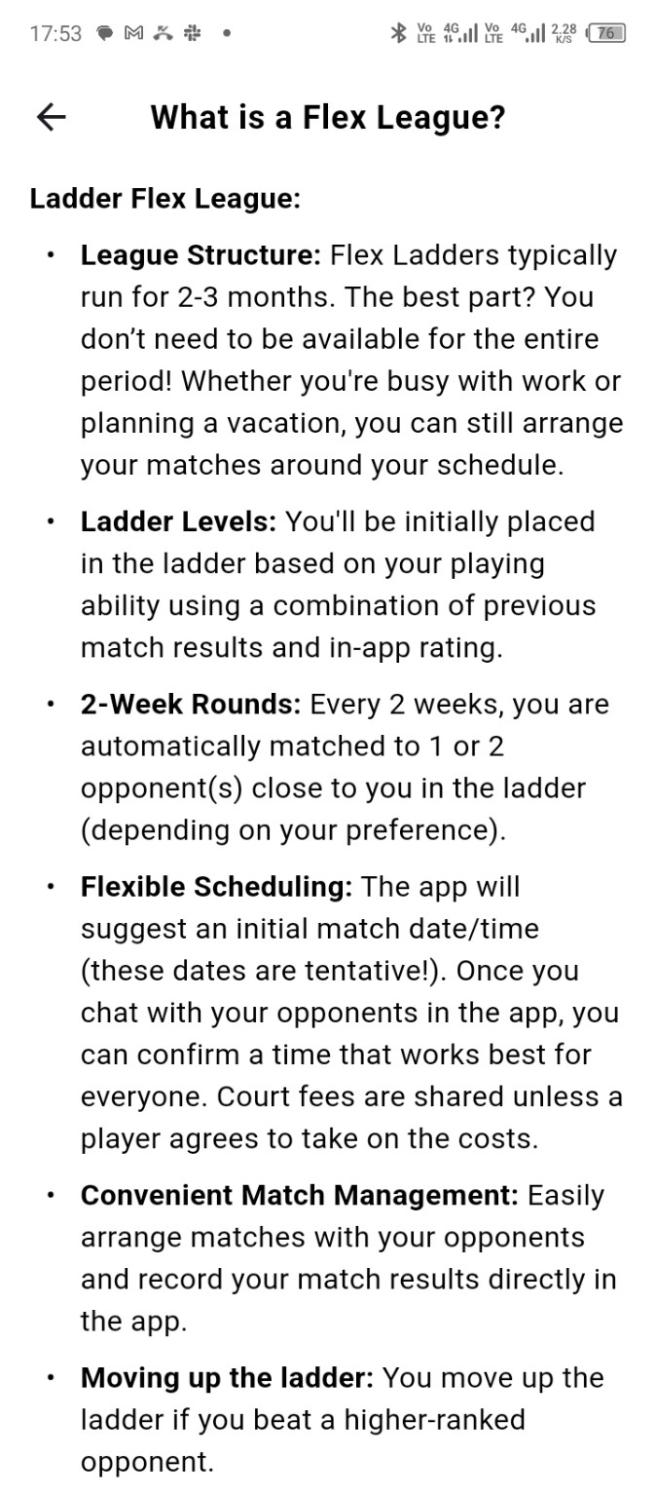
Scala reference — 1001832917.jpg | Scala reference — 1001832939.jpg

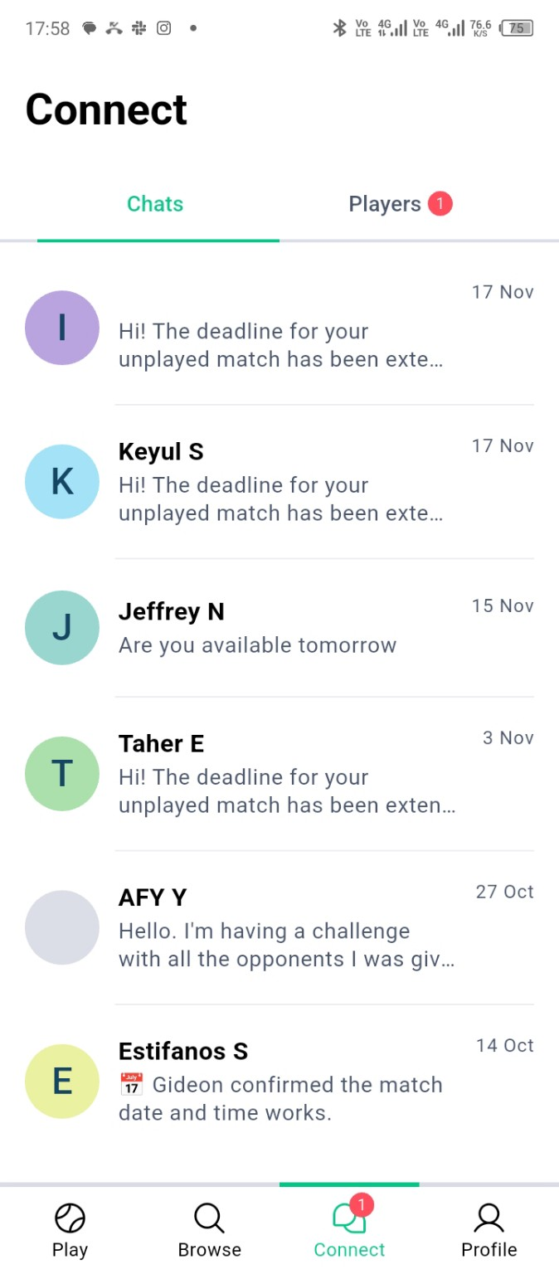 | 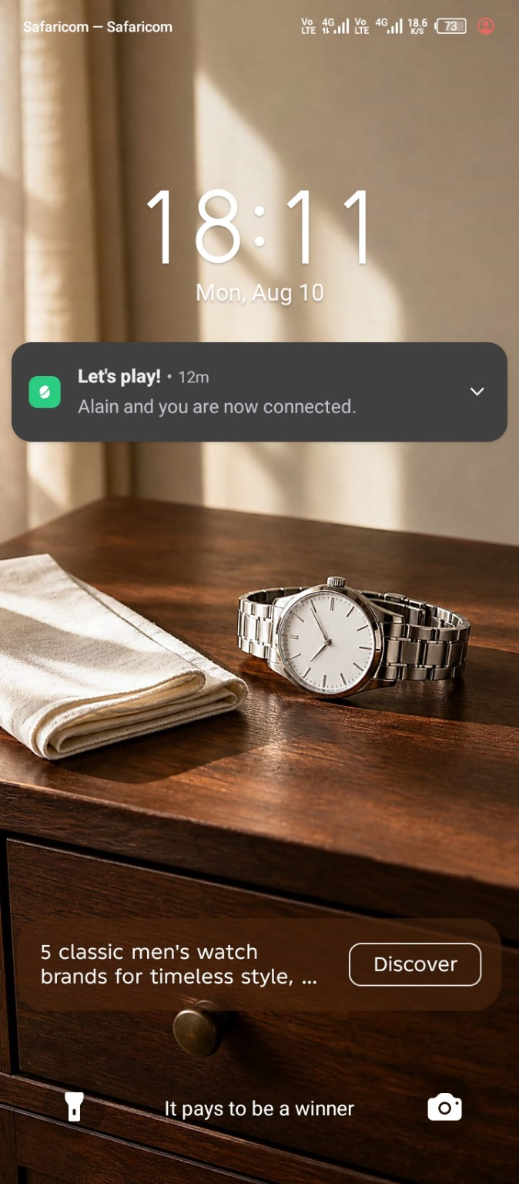
Scala reference — 1001832955.jpg | Scala reference — 1001832975.jpg

11. User Journey & Experience Flows
The proposed journey connects competition, community, courts, learning, news and measurable player development into a recurring engagement loop.
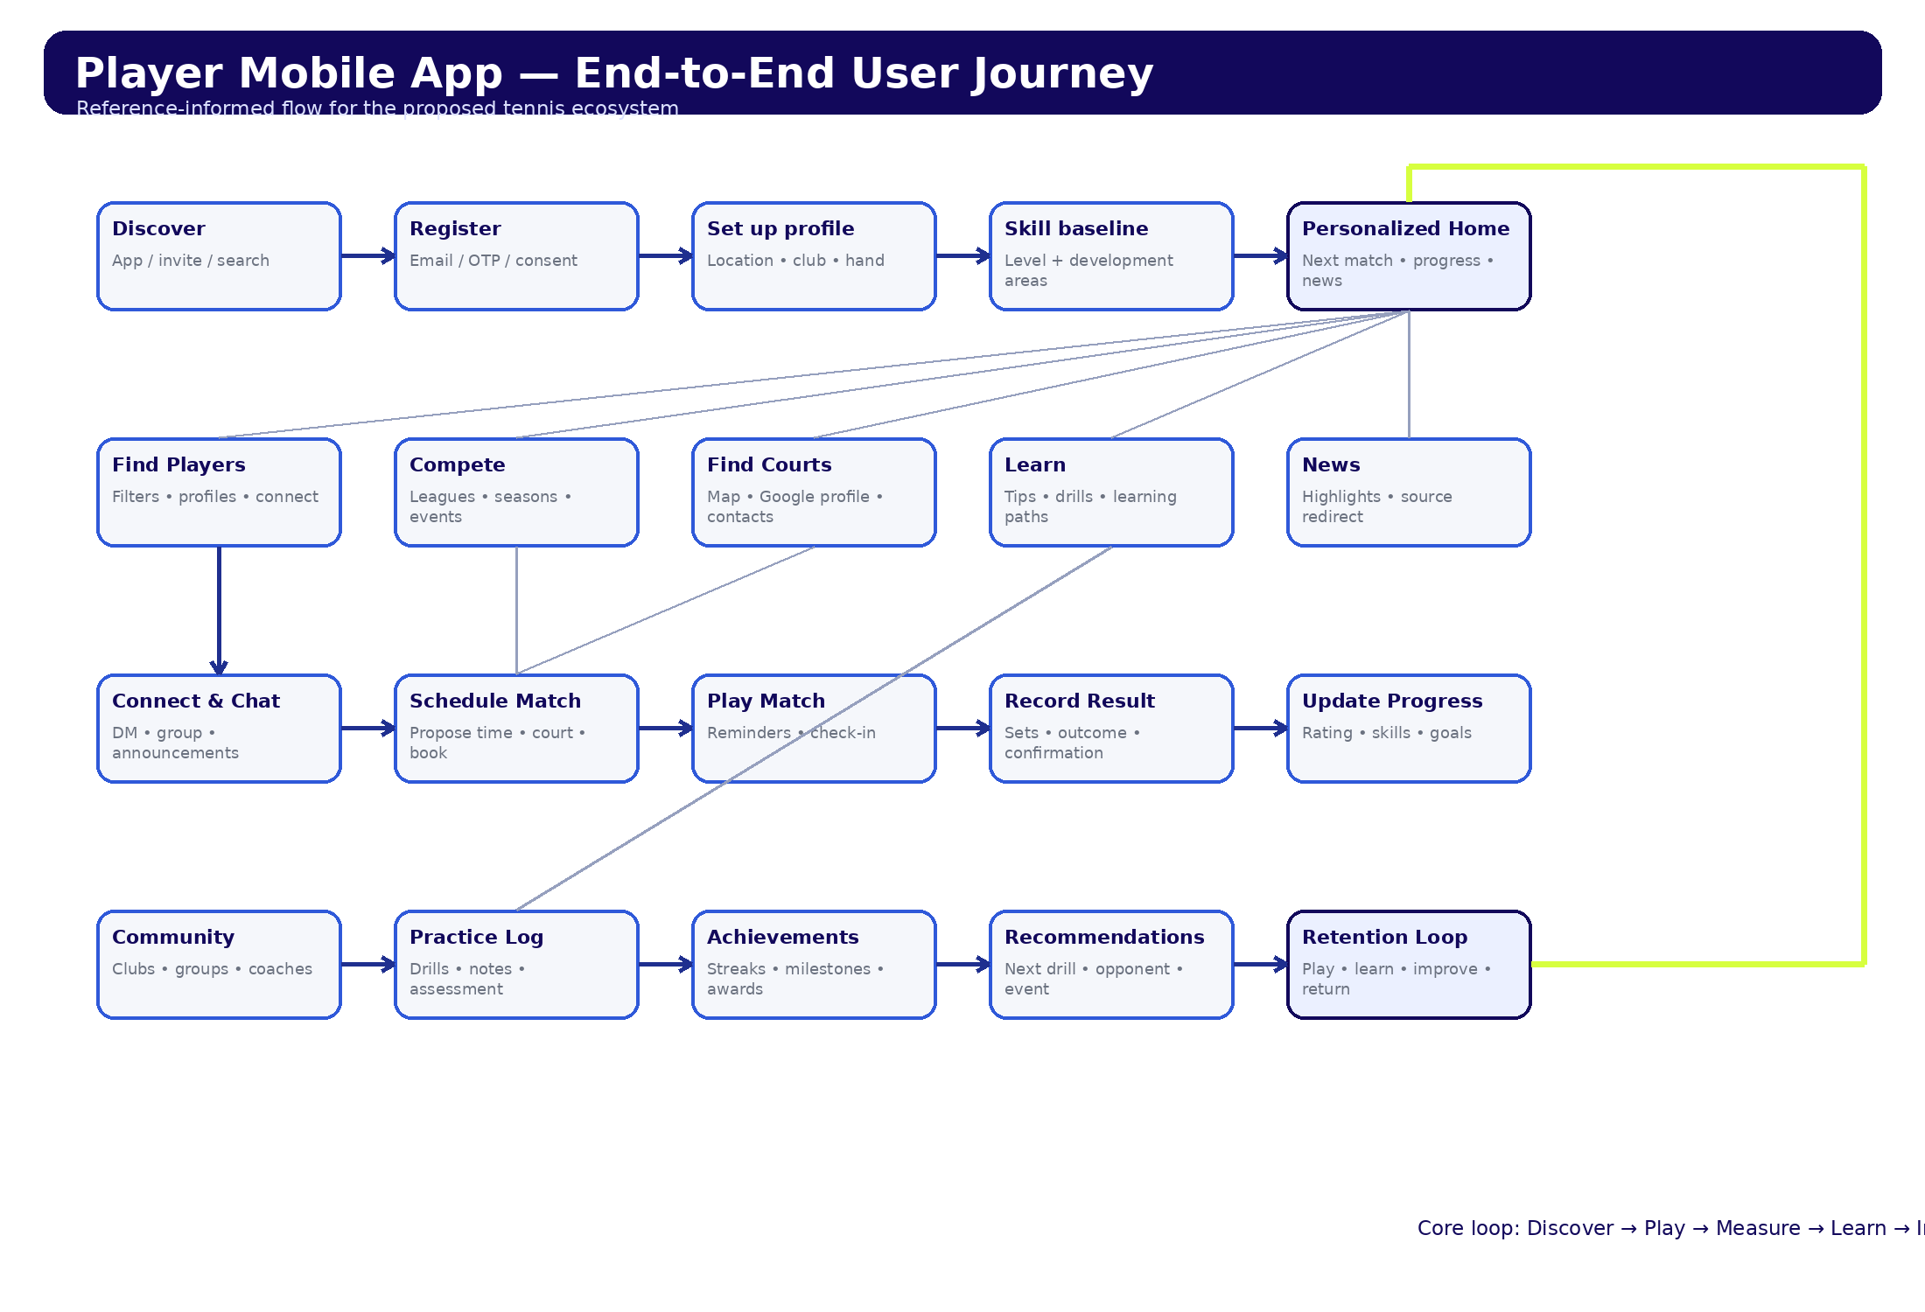
Figure 1. Proposed end-to-end player journey.

11.1 Primary Player Journey
1. Discover the platform and register
2. Verify account and complete privacy/consent choices
3. Set player profile, city/area, club and playing preferences
4. Complete competitive level and skill-development baseline
5. Land on a personalized Home showing the next best action
6. Discover players, competitions, courts, coaches, learning or news
7. Connect/message an opponent or enroll in a league/event
8. Propose a time and court; use booking/contact options where available
9. Play the match and record the result
10. Confirm/verify the result and update standings/rating
11. Log practice and update skill progress/goals
12. Receive recommendations for the next opponent, drill, court, event or learning item
13. Repeat the play-learn-improve loop

11.2 Competition Journey
- Browse league/tournament/event → view rules, dates, level and organizer
- Register / join waitlist → confirmation → enrollment status
- Season starts → round/opponents generated → official announcement
- Contact opponent → propose availability → choose court → confirm match
- Reminder → play → enter score/outcome → opponent confirmation or dispute
- Standings/rating update → next round → season completion → awards/history

11.3 Court Discovery & Booking Journey
- Open Courts → map/list based on approximate location
- Filter by distance, surface, indoor/outdoor, lights, accessibility, price, coaching and availability
- Open venue profile → Google Business data where licensed/available, amenities, photos, opening hours and contact details
- Choose booking route: call, WhatsApp, external booking URL or native booking for partner venues
- Confirm booking → add to match → notify opponent → calendar/reminder
- After visit: save venue, report incorrect data or leave platform-native feedback where supported

11.4 Learning & Skill Growth Journey
- Baseline assessment → choose goals
- Recommended learning path by level and target skill
- Complete tip/video/drill → log practice result
- Optional coach assessment / match reflection
- Skill trend updates for Serve, Forehand, Backhand, Volley, Return, Movement and Match Play
- Next recommendation generated from goals, practice and match history

11.5 News Journey
- Personalized news feed from approved sources
- Headline + source + image/metadata + short platform-generated highlight
- Follow players/tournaments/topics; save/share stories
- Read full story via publisher link/in-app browser when permitted
- Use RSS/APIs/licensed feeds where possible; do not republish full articles without rights

12. Updated Product Information Architecture

Mobile App — Flutter
- Home
- Compete: Matches, Leagues, Tournaments, Events, Rankings
- Discover: Players, Courts, Clubs, Coaches, News
- Learn: Paths, Skills, Drills, Saved
- Progress: Skill Profile, Goals, Practice Log, Assessments, Reports
- Community: Connections, Direct Messages, Groups, Announcements
- Notifications
- Profile & Settings

Club/Community Web — Next.js
- Overview
- Members & Roles
- Leagues / Seasons / Rounds
- Tournaments & Events
- Fixtures / Results / Disputes
- Standings & Ratings
- Courts / Venues / Booking Links
- Coaches
- Announcements & Communications
- Content / Learning Resources
- Reports & Analytics
- Organization Settings

Platform Admin — Next.js
- Platform Overview
- Users & Moderation
- Organizations / Clubs / Communities
- Competitions
- Venues & Court Verification
- News Sources / Ingestion / Moderation
- Learning Content
- Coaches / Verification
- Subscriptions / Payments / Revenue
- Notifications
- Reports / Analytics
- Configuration / Feature Flags
- Audit Logs / Security / Support

13. Updated Screen Design Inventory

Mobile App — Flutter
Area | Screens / states
Access & Onboarding | Splash; Welcome; Sign in; Sign up; OTP; Forgot password; Consent; Location permission; Notification permission; Profile setup; Club selection; Playing hand; Competitive level; Skill baseline; Goals; Onboarding complete
Home & Notifications | Personalized Home; Upcoming match; Recommendations; Quick actions; Notification centre; Notification detail
Compete | Competition browse; Filters; League detail; Rules; Season detail; Player list; Registration; Registration success; Waitlist; Standings; Results; Schedule; Round detail; Match detail; Schedule match; Propose time; Select court; Confirmation; Enter result; Result confirmation; Dispute; Walkover/retirement/no-show; Tournament browse/detail/draw; Event browse/detail/registration
Players & Community | Player search; Nearby players; Filters; Player profile; Connect request; Connections; Pending requests; Inbox; Direct chat; Group chat; Announcements; New message; Report/block
Courts & Clubs | Court map; Court list; Filters; Venue profile; Photos; Amenities; Opening hours; Google profile data; Booking/contact options; External booking; Native booking; Booking confirmation; Saved courts; Club profile; Coach list
Learn | Learning home; Learning path; Skill category; Lesson detail; Video/tip; Drill detail; Saved lessons; Completion; Coach feedback
Progress | Progress dashboard; Skill profile; Skill detail; Baseline assessment; Goal list/detail/create; Practice log; Log session; Match reflection; Assessment history; Achievements; Progress report
News | News home; For You; Topic/player feed; Article highlight; Source web view/redirect; Saved stories; Follow topics
Profile & Settings | Own profile; Edit profile; Ratings; Stats; Match history; Achievements; Privacy; Availability; Preferred courts; Notification preferences; Account/security; Help/FAQ; About; Sign out/delete account

Club/Community Admin — Next.js
Area | Screens / states
Access | Sign in; Password reset; Invite acceptance; Organization setup
Overview | Dashboard; Activity; Tasks/alerts
Members | Member list; Member detail; Invitations; Roles/permissions; Eligibility
Competition | League list/create/edit; Season setup; Registration; Waitlist; Round generation; Fixtures; Match detail; Result review; Disputes; Standings; Rules/scoring; Awards; Archive
Events | Event list/create/detail; Registrations; Attendance; Organizer profile
Venues | Court list/detail; Amenities; Booking contacts; Booking links; Availability; Venue verification request
Coaches | Coach list/detail; Schedule/availability
Communication | Announcements; Templates; Group messages; Notification history
Analytics | Participation; Match completion; Retention; Venue usage; Exports
Settings | Organization profile; Branding; Integrations; Billing; Audit log

Platform Admin — Next.js
Area | Screens / states
Operations | Executive dashboard; Platform activity; Alerts
Identity | Users; User detail; Roles; Suspensions; Reports
Organizations | Clubs/communities; Verification; Admins; Plans
Competitions | Global competitions; Rulesets; Disputes/escalations
Venues | Venue directory; Duplicate resolution; Google metadata status; Verification
Content | News sources; Ingestion jobs; Story moderation; Learning library; Categories/tags
Commercial | Plans; Subscriptions; Payments; Commissions; Promotions
Trust & Safety | Reports; Moderation queue; Block/abuse cases
Platform | Countries/cities; Feature flags; Notification templates; Integrations; API health; Audit logs; Support tickets; Analytics

14. Brand & Design System Update
Visual direction: premium professional tennis, inspired by the confidence and deep-blue feel of ATP interfaces while remaining visually independent and original.
Token | Value | Usage
Primary Blue | #12085B | Primary navigation, headers, primary actions, active states
Secondary Blue | #1F2F8F | Secondary surfaces and interaction states
Accent Blue | #2F59D9 | Links, charts, progress and interactive highlights
Tennis Accent | #D7FF3F | Sparingly for live states, achievements and priority highlights
Background | #FFFFFF / #F5F7FB | Primary and secondary surfaces
Text | #111827 / #6B7280 | Primary and secondary text
Border | #E5E7EB | Dividers, outlines and neutral controls
- Primary typeface: Inter; alternatives Manrope, Plus Jakarta Sans or IBM Plex Sans.
- 8px spacing system; 12–16px typical card/control radii; restrained shadows and gradients.
- Reusable tokens/components shared conceptually across Flutter and Next.js implementations.
- WCAG 2.2 AA target, including contrast, focus states, keyboard support on web and adequate touch targets.
- Professional tennis imagery and motion used to communicate movement, progression and competition without visual clutter.

Product Scope Update: Tennis + Padel
The platform will launch as a multi-sport racket-sports ecosystem supporting Tennis and Padel. A member may participate in Tennis, Padel, or both while maintaining one account and one platform identity. Sport-specific ratings, assessments, match histories, statistics, competitions, learning content, preferences, achievements and development profiles remain separate.

Sport-Aware Product Model
- User Account: identity, authentication, communication preferences and platform-wide settings.
- Sport Profile: one profile per enabled sport (Tennis and/or Padel).
- Sport Rating: competitive strength derived increasingly from verified match results.
- Development Profile: technique and development measures specific to the selected sport.
- Sport Preferences: formats, competitive/social preference, availability, preferred clubs/courts and goals.

Adaptive Onboarding & Initial Level Assessment
Onboarding must do more than collect registration data. It should establish a credible starting level, understand the player's goals and preferences, and generate useful first recommendations. The Scala reference screens inform the concept of guided level estimation, but the implementation and wording must be original.
Welcome → Create Account → Verify Email / Phone → Basic Profile → Choose Sport(s) → Tennis Assessment and/or Padel Assessment → Playing Experience → Adaptive Skill Questions → Playing Preferences → Goals → Location → Club / Preferred Courts → Availability → Initial Level Calculation → Review Suggested Level → Confirm / Adjust Level → Personalised Player Profile → Recommended Next Actions → Home

Sport Selection
Question: What do you play?
- Tennis
- Padel
- Both
Selecting Both triggers separate assessments. Users can add another sport later without recreating their account.

Shared Experience Questions
Playing experience: New; <6 months; 6–12 months; 1–2 years; 2–5 years; 5+ years; competitive/advanced.
Frequency: Rarely; a few times/month; weekly; 2–3 times/week; 4+ times/week.
Competition experience: Never; social; club; local; regional; national; elite/professional.
Existing rating: Capture recognised rating system and value where available; retain as a signal, not unquestioned truth.

Tennis Assessment Dimensions
- Forehand
- Backhand
- Serve
- Return
- Volley / Net Play
- Movement / Footwork
- Match Play / Tactical Awareness

Padel Assessment Dimensions
- Rally consistency
- Forehand
- Backhand
- Serve
- Return
- Volley
- Overhead
- Bandeja
- Vibora
- Smash
- Wall usage
- Double-wall situations
- Positioning
- Net control
- Transition
- Partner communication
- Defensive play
- Shot selection
- Tactical awareness
- Match experience

Adaptive Question Logic
The assessment must branch dynamically. Beginners receive a shorter, plain-language assessment; experienced players receive deeper questions that distinguish intermediate, advanced and competitive ability. Advanced Padel techniques such as bandeja or vibora should not be asked of users whose earlier answers indicate beginner status.
Prefer behavioural questions over arbitrary 1–10 self-ratings. Example: "When rallying from the baseline, what usually happens?" Answers should progress from difficulty keeping the ball in play through controlled rallies, direction/depth, variation, attack and execution under pressure.

Assessment Result & Rating Model
At completion, show a suggested starting level with a short explanation and a skill breakdown. Allow the player to confirm or adjust the suggested level. Store System Suggested Level and User Selected Level separately.
Competitive Rating and Skill Development are separate concepts. Competitive Rating answers how strong the player is relative to others; Development Profile shows which parts of the player's game are improving.

Development Profiles
Tennis development profile:
- Serve
- Forehand
- Backhand
- Return
- Net Play
- Movement
- Match Play
Padel development profile:
- Serve/Return
- Groundstrokes
- Volley
- Overheads
- Walls
- Positioning
- Net Control
- Transitions
- Partner Play
- Tactics

Goals & Preferences
- Learn the sport
- Improve technique
- Get fitter
- Play socially
- Meet players
- Play more regularly
- Improve rating
- Join leagues
- Play tournaments
- Find coaching
- Track improvement
Tennis preferences include Singles, Doubles or Both. Padel preferences include social/competitive preference, preferred side where relevant and partner preferences. Both sports capture preferred playing times and availability.

Post-Onboarding Personalisation
Do not land a new member on an empty dashboard. Generate sport-aware next actions such as Find Players, Find Courts, Join a League, Start Training, Set a Goal, Find a Coach, or Play a First Match based on sport, level, goals, location and availability.

Design System Implications
The design system remains shared across the ecosystem, with #1C91D0 as the primary brand colour. Sport context should be communicated through labels, iconography, content and imagery rather than creating unrelated visual systems.
Primary brand colour: #1C91D0
- Create sport-aware components such as Sport Switcher, Sport Profile Card, Rating Card, Skill Assessment Question, Skill Breakdown and Sport Badge.
- All shared components must support Tennis and Padel content without hard-coded tennis terminology.
- Navigation and filters should expose the active sport where context could otherwise be ambiguous.
- Admin competition setup must require sport selection and expose sport-specific rules/formats.

Revised Core User Journey
Discover → Register → Choose Tennis / Padel / Both → Create Sport Profile → Adaptive Level Assessment → Set Goals & Preferences → Location / Clubs / Courts → Suggested Level → Confirm → Personalised Home → Find Player / Competition / Court → Connect → Schedule → Play → Record Result → Update Rating & Stats → Reflect on Skills → Practice / Learn → Track Progress → Find Next Match → Repeat

